



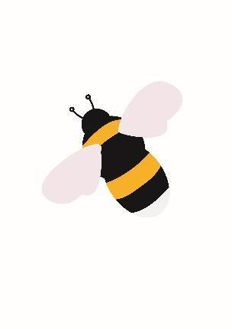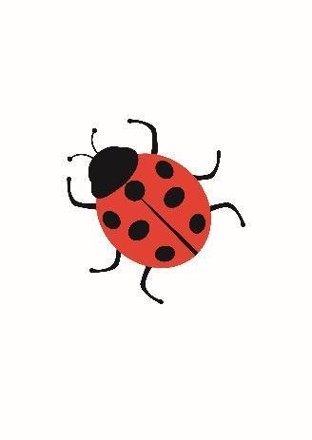

Welcome to Reception

The children are settling in well and are learning all the new routines. Over the next few weeks, we will be assessing your child so we know where they need to start their learning. We will also be interacting with them in the areas of provision, getting to know them and helping them to make new friends.

**Phonics**

In phonics, we will start to learn the single letter phonemes (letter sounds): for example, s, a, p. The children will learn the action, the sound and how the letter is formed. Your child should come home wearing a ‘sound button’ sticker. If you press the button on the sticker, your child should make the correct sound for the letter. At the end of each week your child will bring home some flashcards of the sounds they have been learning. Please use them to practise the sounds and create words. 

**Reading and Phonics Meeting**

We will be holding a Reading and Phonics meeting on **Wednesday 11th October** at 2.45pm in the infant hall and at 6pm online using Google Meet. We will explain about how we teach reading and phonics. We would like everyone to attend one of the meetings please as you will gain some important knowledge to help support your child. More details will be sent home soon.

**Library**

The children will visit the school library every **Friday**. Library books are chosen by the children and can be read to the children by family and friends. Please return your library books every Friday.

**Bookbags**

Please ensure book bags are brought to school every **day.**

**Maths**

We will be mastering the value of numbers 0 to 10. This will entail reading the numbers, showing the value of the numbers and representing the numbers in many different ways. We will also complete lots of counting exercises, counting forwards and backwards from 10. You may be surprised how long we spend on each number: this is to ensure that each number is really ‘mastered’ and understood in depth. We will be holding a maths meeting on **Wednesday 22nd November** at 2.45pm in the infant hall and at 6pm online using Google Meet. We will explain about how we teach maths and how you can support your child at home.

**EyLog**

We use EyLog to record observations of your child in school. You will shortly receive a letter requesting your permission to link your email address to your child’s account. You will also receive a password to set up your own account to view and add observations of your child.

**Reception News**

Every **Friday** we will send you an email and share with you the Reception News page from the school website. This will show you what the children have been learning and enjoying each week.

**Home School Links**

Home school links are very important for the children’s happiness and development. Please do look at Reception News post with your child and sometimes leave us comments to share with the children. The children will soon receive their Home Learning Book. Every week, we will be set an open-ended task linked to the children’s learning that week which is to be completed in a fun way at home. If you have any questions about this, please don’t hesitate to ask. Home Learning Books are to be handed in on a **Thursday** morning and will be handed back on a **Friday** afternoon**.**

**P.E.**

We will start PE on **Friday 22nd September**. In the Autumn term we will be doing PE inside the school hall, so the children only require a pair of black shorts and a white t-shirt. Their PE bag can stay on their peg. We would be grateful if you would continue to practise getting dressed and undressed at home.

**Clothing**

Please can you make sure that your child comes to school in appropriate footwear, coats, hats, gloves etc… as we will be going outside in most weather! Would you also please make sure that all clothing is clearly labelled. You can send wellies for your child to wear, but we do have some in school. Please make sure your child can put their coat on and fasten it independently.

**Snacks**

Please can your child bring a labelled water bottle each day. They can also bring a healthy fruit or vegetable snack – please make sure that any snack boxes are labelled too.

**Contact Details**

We hope that your child will have lots of fun in Reception. If you have any concerns, please either talk to any of the staff in the class or you can email us on:

Mrs Kumar – [hannah.kumar@farsleyfarfield.org.uk](mailto:hannah.kumar@farsleyfarfield.org.uk)

(Works Monday/Tuesday/Wednesday)

Mrs Galbraith – [alexandra.galbraith@farsleyfarfield.org.uk](mailto:alexandra.galbraith@farsleyfarfield.org.uk)

(Works Monday/Wednesday/Thursday/Friday)

Miss Pinnock – [sabrina.pinnock@farsleyfarfield.org.uk](mailto:sabrina.pinnock@farsleyfarfield.org.uk)

(Works Tuesday/Wednesday/Thursday/Friday)

Thank you for supporting your child so that they are happy learners in Reception.

The Reception Team