



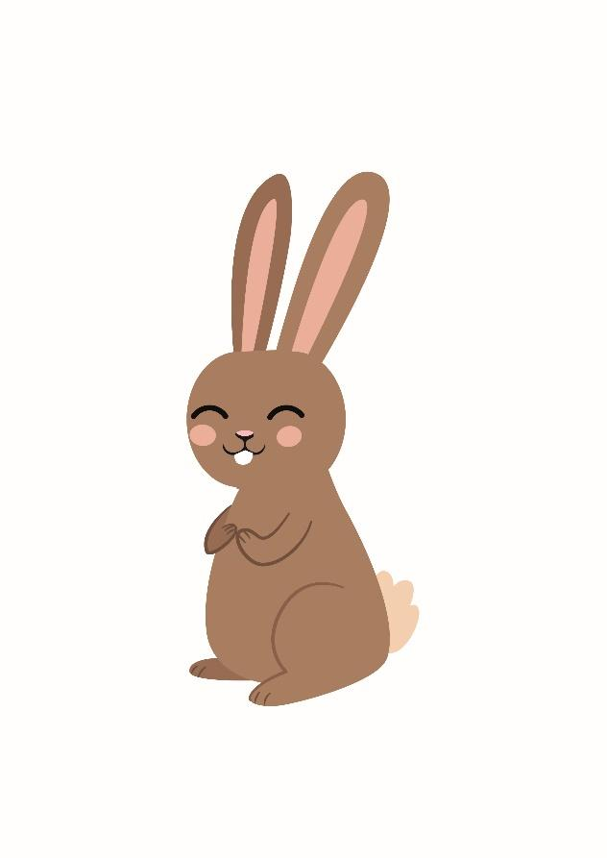

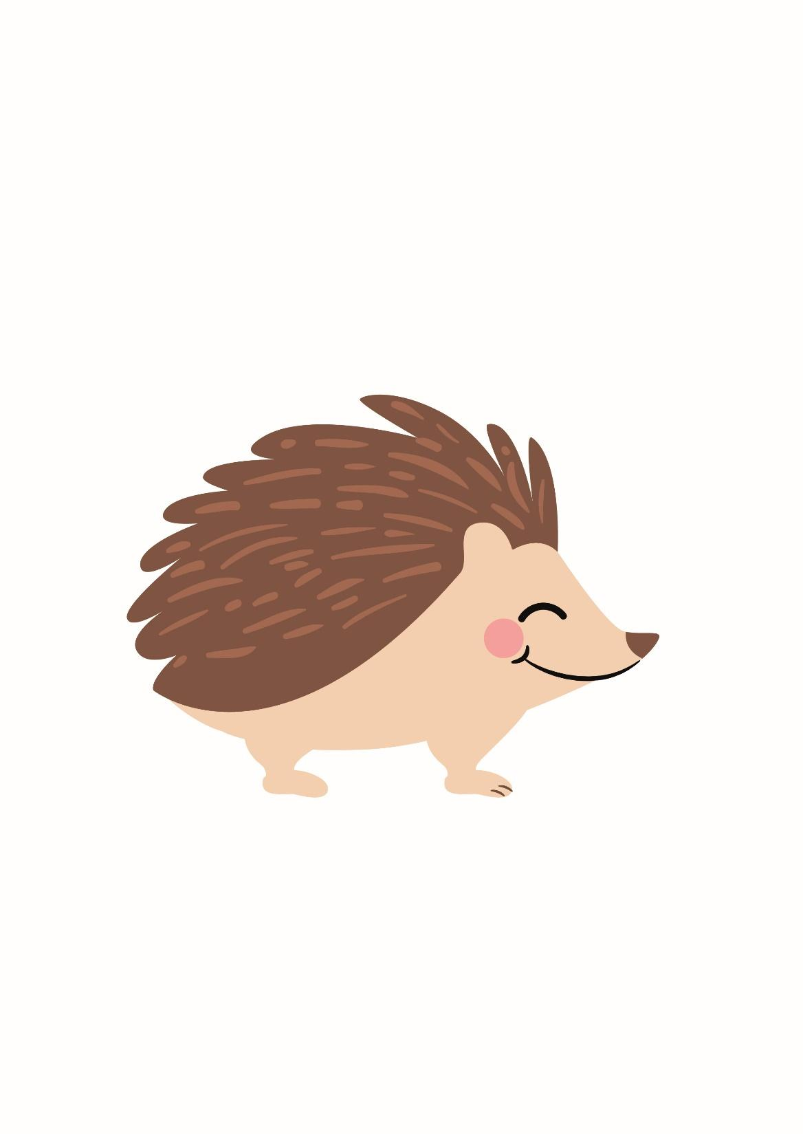

Welcome to Year 1

**Staffing**

In 1B, rabbit class, Mrs Broadhead is the class teacher. Other adults in the class providing support are Mrs Booth and Miss Massanet. In 1T, hedgehog class, Mrs Tomlinson will be teaching the class. The teaching assistant supporting in the class is Mrs Thornton.

On Friday afternoons the children will be working in small groups with different members of staff. They will do lots of exciting activities including RE, music and nature walks. Please could your child bring a pair of named wellington boots to leave in school ready for their nature walks.

**Morning and Home time**

Our doors open at 8.45am in the morning and we finish at 3:15 in the afternoon. Please bear with us at home time; we will get quicker once we get to know you all!

**Curriculum**

Our first topics are ‘All About Me’ and ‘Autumn and Harvest’. We have lots of exciting learning planned. As part of our history lessons we will be looking at how we have changed. We would like everyone to bring in one named baby/toddler photo to help with these discussions.

In our English lessons we will enjoy reading ‘Oliver’s Vegetables’ and ‘Kitchen Disco’. In maths we will be learning about place value as well as addition and subtraction. In our science lessons we will be visiting the farm. We will also be ‘plant detectives’ and make some delicious vegetable soup! Yum! All our curriculum can be viewed in the Curriculum section of the main school website.

**Reading**

We are busy hearing all the children read individually. In their book bag they will have a reading book and a new reading record. Please read with your child at least four times a week and write in the reading record so we know what you have read. Please keep the reading book and record in your child’s book bag during the week as we can never predict on which day of the week we will read with them. We will change the children’s home reading books every **Friday**.

**Library**

As well as the home reading books, we have a good selection of library books for children to borrow and enjoy at home. Your child will choose their own book to share with you at home. Our library day is **Friday**.

**PE**

In Year 1 the children participate in PE sessions twice a week. We will be doing PE on Mondays and Thursdays. Please make sure that your child wears their PE kit to school. If the weather is fine, we will do one of our PE sessions outside so please make sure that they have appropriate footwear. Please remember to label all their clothing so that items don’t get lost!

**Homework and Spelling Books**

Your child will bring home their homework book in the next few weeks. In the book there will be a short task for your child to complete with an adult at home. The book stays at home for 2 weeks. On the alternate week a spelling book will be sent home. It will have a spelling pattern for your child to investigate e.g. ee to make words such as ‘feet’ or key words to learn. This is to help your child to develop their understanding of spelling and practise their cursive letter formation – there will not be a spelling test.

**Visits and Visitors**

Throughout the year, to enhance the children’s learning and to gain first hand experiences, we will arrange for a trip out of school or take part in a workshop run by visitors in school. Lots of these will be free, however, some will require some contribution from parents. Please see the table below for the main visits and visitors in Year 1 this year:

|  |  |  |
| --- | --- | --- |
| Half term | Visit or visitor | Approximate cost |
| Autumn 1 |  |  |
| Autumn 2 | Visit to St John’s Church  Great Fire of London Workshop | Free  £6.00 |
| Spring 1 | Visit to Leeds Art Gallery  Glass Workshop | Free  £7.00 |
| Spring 2 |  |  |
| Summer 1 |  |  |
| Summer 2 | Animal Workshop  Rodley Nature Reserve | £4.00  Donation |

We will send home more detailed letters about each event. We may need parent volunteers to help us with our visits out of school.

**Year 1 Blog**

Every **Friday** we will update the Year 1 blog and inform you what your child has been learning about. We will also regularly post photographs and write about all the exciting things we do in Year 1. We will share the blog with your child and encourage them to look at it at home with family and friends. Please take the time to read our blog and leave a comment – the children get very excited when they see a new message! Alternatively, just give the post a ‘thumbs up’ to show that the blog has been read.

Our blog can be found on the school website [www.farsleyfarfield.org.uk](http://www.farsleyfarfield.org.uk). Just click on the menu and then click class blogs and find the Year 1 page (the menus work slightly differently on a desktop machine compared to a mobile). If you have registered your email address, you will get notification of a new blog post from us every Friday. Happy blogging!

We hope that your child will have lots of fun in Year 1. If you have any concerns, please either talk to any of the staff in the class or you can email us on: [rebecca.broadhead@farsleyfarfield.org.uk](mailto:rebecca.broadhead@farsleyfarfield.org.uk) or [emma.tomlinson@farsleyfarfield.org.uk](mailto:emma.tomlinson@farsleyfarfield.org.uk)

Thank you for supporting your child so that they are happy learners in Year 1,

The Year 1 Team