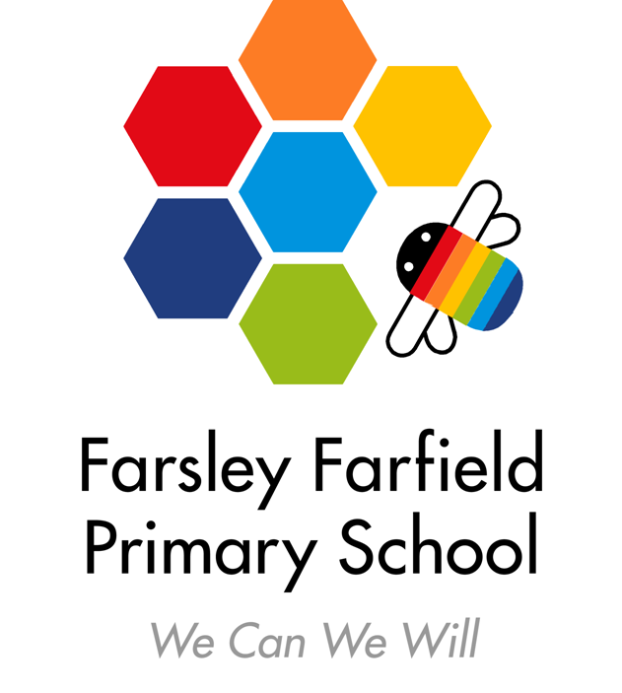
Farsley Farfield Primary School
Cote Lane, Farsley, Leeds LS28 5ED
Infants: Telephone 0113 2058133
Juniors: Telephone: 0113 2058130
E-mail: office@farsleyfarfield.org.uk

Wednesday 20th December 2023

Dear Parents/Carers,

We are very excited to have booked a glass workshop with Twice Fired. This will enhance our learning about art and artists. The Twice Fired team will come into school to deliver the workshops. It’s going to be an amazing afternoon and each child will take home a personalised piece of glass work (once it has been fired).
The workshops will take place on Tuesday 9th January 2024 – 1B and Wednesday 10th January 2024 – 1T.
The cost is £6.60 per child. We are required to remind you that this contribution is genuinely voluntary and a parent is under no obligation to pay. However, in order for the workshops to be financially viable, we will require the large majority of parents to make the voluntary contribution. If we do not receive enough contributions, then the workshops may have to be cancelled. Please can all payments be made by Monday 8th January 2024.
We would like parents to pay using our online payment system – ParentPay. If you need a reminder of your log in details please contact the office.
Yours faithfully,

The Year 1 Team

