Year 1 Newsletter


January 2024








Happy New Year! We hope you all had a lovely holiday. The children have settled back in well and are all working hard.

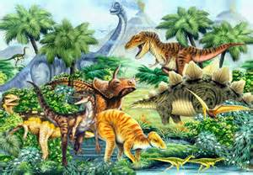
Dinosaurs
In English we are beginning by focussing on ‘Dinosaurs’. We will be reading and writing our own information books. We have transformed our role play areas into dinosaur lands. We then move onto writing stories based on the book ‘Katie’s Picture Show’.

Art Gallery
Our new topic is ‘What happens in an Art Gallery?’ Over the half term the children will learn many different art skills including sculpture, collage and printing. We will also be looking at the work of Pacita Abad and Henri Matisse.
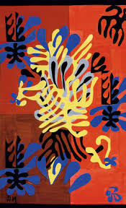



Reading
Thank you for your support with reading at home. Please remember to write in the record book when you hear your child read. We do check these regularly, but keep our own separate detailed records of children’s reading progress in school. Please make sure that your child’s reading record and books are in their bag every day. Please continue to use Fast Phonics.

Maths

We will focus on numbers within 50 and addition and subtraction with 20. We have been working hard to problem solve and we will continue solving addition and subtraction problems this half term. Remember there are lots of activities on Mathletics to support your child’s learning.

RE
In our RE lessons we are learning about celebrations. We would like it if all the children could share a photograph of them at a celebration such as a wedding, christening, Eid, Diwali, a birthday party, conformation, bonfire party, Christmas, Easter or any other celebration they have enjoyed. You can email your photograph to emma.tomlinson@farsleyfarfield.org.uk or rebecca.broadhead@farsleyfarfield.org.uk

PE
Please make sure that your child comes to school in their PE kit every Monday and Thursday. If the weather is fine, we will do one of our PE sessions outside so please make sure that they have appropriate footwear and warm clothing. Remember to label all their clothing so that items don’t get lost.

Year 1 Blog
Do you look at the Year 1 blog? We do a weekly post every Friday which includes what has been taught that week with lots of photographs. Please have a look at what your child is doing in school. If you don’t get email alerts about new postings on the blog, please register your email address with the office.

We are looking forward to another busy and exciting half term in Year 1. If you have any concerns please either talk to any of the staff in the class or you can email us on –Rebecca.broadhead@farsleyfarfield.org.uk and emma.tomlinson@farsleyfarfield.org.uk

Thank you for all your support,
The Year 1 Team

