**Behaviour Policy- September 2023**

___________________________________________________________________________

At Farsley Farfield we want our children to learn about their own behaviour and the behaviour of others. They are encouraged to talk about issues and listen to others’ points of view as well as share their own. We want children to understand the consequences of actions, both positive and negative, so that they are able to make the right choices and feel good about it.

________________________________________________________________

**Aims**

The Governors and staff believe and aim to:

∙ Seek and create a happy atmosphere in school

∙ Praise children for positive behaviour choices and for maintaining high standards

∙ Produce few yet clear rules, which are clearly understood and accepted by all

∙ Encourage self-discipline from the earliest possible age

∙ Prevent poor behaviour choices rather than devising sanctions for use after the event

∙ Involve parents at an early stage

∙ Give appropriate consequences to meet the misdemeanour

∙ Develop clearly stated boundaries through the ‘**Learning Hive'**, where adults respond promptly and firmly to children testing these boundaries

∙ Provide additional support to help children understand and maintain good behaviour choices

___________________________________________________________________________

**School Ethos**

The school ethos is central to establishing and maintaining high standards of behaviour. It is based on the quality of relationships between staff, children, parents and governors. Adults should respect children and their ideas, and then children will learn from these examples. Where clear expectations are co-operatively agreed and followed, the communal sense of purpose is a source of strength. Children know what is expected of them and are encouraged to see school as a positive ‘**Learning Hive**’.

**School Expectations**

The ‘**Learning Hive**’ pulls together key aspects of a child’s personal development in our school.

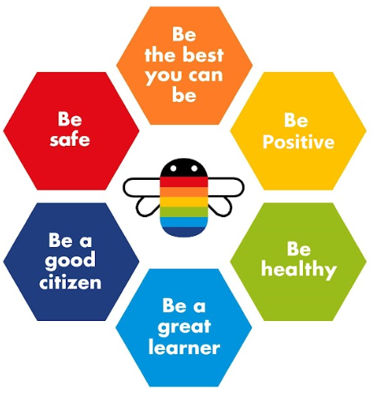

Our **school rules** apply to all members of the school community in every part of the day.

Not everything forbidden must be governed by a rule, and rules cannot cover everything. But our core set of rules create a skeleton for good conduct and show how to become part of our **‘Learning Hive**’.

|  |  |
| --- | --- |
| **FARSLEY FARFIELD SCHOOL RULES** | |
| **READY**  We show we are **READY** to learn and show a positive attitude to our learning. |  |
| **RESPECTFUL**  We act and speak in a polite and **RESPECTFUL** way to all members of the school community. |  |
| **KIND**  We use **KIND** words and actions. We are **KIND** to others and to ourselves. |  |

**Behaviour of Adults**

*‘Let’s stop waiting for the magic behaviour solution. It isn’t coming. The answer lies in the ability of adults to deliver behaviour policy and practice that is simple, highly effective and utterly consistent.’ (Paul Dix, When the Adults Change, 2018 p3)*

Our children have told us what they want from adults in school. The most common responses were:

**Fair Kind Respectful Fun Clear Brave**

All adults have a duty of care to maintain good order and to safeguard children’s health and safety. It is the adults who determine the environment in which good relationships can flourish. At the centre is mutual respect between adult and child.

**We expect every adult to**:

**1. Meet and greet** positively and in a personal way at the start of the day and after breaks and lunchtimes.

**2.** Refer to the **school rules**.

**3. Model** positive behaviours and build relationships.

**4. Plan** learning that engages, challenges and meets the needs of all children.

**5.** Use a **visible recognition** mechanism throughout every lesson (eg, Recognition boards or a ‘Honeypot’)

**6.** Be **calm** and give ‘take up time’ when correcting poor choices.

**7. Follow** up every time, retain ownership and engage in reflective dialogue with children.

**8. Never ignore** or walk past children who are making poor behaviour choices.

**Leaders**

Leaders are not expected to deal with behaviour incidents in isolation. Rather they are to stand alongside colleagues to support, guide, model and show a unified consistency to the children.

**We expect every leader to:**

• Take time to **welcome** children and families at the start of the day

• Be a visible presence around the site and especially at transition times (e.g. break times)

• **Celebrate** adults and children whose effort goes **over and above** expectations

• Regularly share good practice

• **Support** staff in managing children with more complex or entrenched negative behaviours

• Use behaviour data (recorded on CPOMS) to target and assess school wide behaviour policy and

practice

• Regularly review the effectiveness of provision

___________________________________________________________________________

**Recognition and rewards**

We have a positive approach to behaviour management. It is important that children develop an intrinsic reward system as this provides them with the motivation to continue making good choices throughout their lives. Children are rewarded in a way that is meaningful to them, considering their age and needs. As with sanctions, rewards graduate in the level of praise given and children should always be clear about why they are receiving recognition.

We recognise and reward learners who go ‘**over and above’** our standards. Adults understand that the use of praise in developing a positive atmosphere in the school cannot be underestimated and a quiet word of personal praise can be as effective as a larger, more public reward. It is the key to developing positive relationships, including with those learners who are hardest to reach.

“Intrinsic rewards to good behaviour (better learning, the value of the subject in itself) should be prioritised in order to avoid ‘reward fatigue’ where students become desensitised to benefits. External indicators of intrinsic success can be powerful motivators, and reinforce existing norms, for example, prize ceremonies, used judiciously.” *(Tom Bennett Independent Review of Behaviour in Schools.*

Additional Rewards

Where possible we help children to value learning and kindness for its own sake and avoid diminishing this through extrinsic rewards. However, we recognise that, if given in a specific and sincere way, rewards can encourage sustained behaviour change and can be a central component of habit formation. Adults think carefully about the use of rewards, recognising that children feel rewarded through different means. The rewards that most humans value above others are pride, being part of a community, having responsibility, being valued, feeling successful. Examples of additional rewards are:

• Being chosen to lead the line (or other responsibilities).

• First to go out at play time/ lunchtime.

• Dojo points and / or stickers.

• Opportunity the share positive news with another adult who is key for the child.

• Name on recognition board to advertise good learning behaviours.

• Share good news with parents at the end of the day. If parents do not collect, this can be done by telephone.

Dojo Points

Children earn ‘**Dojo Points**’ when they go ‘**over and above’** the standard of behaviour expected in school. All adults can give out Dojo points to recognise and reward positive behaviours but they are never given as a bribe (e.g. “if you finish this work, you can have a Dojo point.”). To ensure consistency, adults only give out 1 Dojo point at a time and they are never taken away from children for poor behaviour choices. The specific use of Dojo points differs slightly in each phase:

**Nursery**- Dojo points are not given in Nursery. Stickers are given to instantly recognise and reward ‘**over and above**’ behaviour choices.

**Reception**- When a child’s name goes onto the recognition board,

the child earns a Dojo point. At the end of the week, the child with the most Dojo points becomes the class Dojo champion and claims a small prize.

**Key Stage One & Two**- Adults use dojos as an instant reward for ‘**over and above**’ behaviour choices and other learning behaviours linked to our learning hive. Each class has a visible recognition board. At the end of the week, the child with the most Dojo points becomes the class Dojo champion and earns a certificate.

Lunchtime Rewards

It is important that behaviour expectations are reinforced at lunchtime. There are a number of activities available to the children which help to promote positive behaviour.

The expectation for positive lunch time behaviour is also reinforced through rewards such as:

* specific verbal praise;
* Dojo points;
* mentions to teaching staff and senior leaders.

Special Mention Assembly

Our Special Mention Assembly is on a Thursday afternoon (Infant building) or Friday afternoon (Junior building), where children are chosen for a Special Mention certificate. These children will have consistently gone **‘over and above’** to demonstrate one area of our Learning Hive during the week.



**Managing Behaviour**

For the vast majority of our children a gentle reminder is all that is needed. Managing poor behaviour choices should always be done with care and consideration, taking individual needs into account where necessary.

Adults praise the behaviour they want to see and always give **’first attention to the best conduct’**. All children must be given **‘take up time’** in between steps.

Managing and modifying poor behaviour choices

Children are held responsible for their behaviour. Adults will address behaviour (where possible without delegating) and will use the steps below for dealing with poor choices. There may be a traffic light display in classrooms to show the steps below but any recording of where a child is on the traffic light system will be kept private.

❶ Check In/ Reminder

This is part of Quality First Teaching and as such can be repeated whenever staff observe a concern. Adults aim to maximise teaching time and minimise disruption by using the least invasive tactic possible to correct poor behaviour.

This step should not be confrontational (body language and facial expressions should be open/ neutral/ positive). This step may help identify if a child has a difficulty in accessing the lesson or is feeling anxious/ upset in any way. Many of our children experience feelings which they cannot name/ understand or link to a cause- they just feel it in the moment.

Adults listen to what the child says and respond, check in after a few minutes and then at intervals. Adults then continue to be observant. Sometimes check-ins are enough. Sometimes the child may just want to be left a while.

**❷ Warning** (**amber** on the school traffic light system)

For some children being given a warning publicly is shaming and they may become defensive or withdrawn, to others it can have status. A private note of a warning can be made by adults if needed but **a warning is never displayed publicly**.

The child receiving a warning should be told on a 1:1 basis (warnings are never displayed publicly) and are given a reason. e.g. *'I need to give you a warning because when you are shouting out, it is so hard for children to hear’*.

Depending on the child and the severity of the behaviour it may be appropriate to repeat a warning.

Adults use strategies to support the child in de-escalating e.g. moving a child away from a situation, reflecting on a previous experience where they have overcome difficulties or, reminder of next activity once this is complete.

Does the child know what is causing the behaviour? How can you help?

**❸ Sanction/ Consequence** (**red** on the school traffic light system)

“The severity of the sanction is less important than the certainty of the sanction. It is very easy to use consequences to get back at students, rather than allow the consequences to ‘teach’ the student that all behaviour has consequences.” Bill Rogers

If poor behaviour choices persist then a sanction will be put in place. While sanctions follow a graduated response, adults in school must use clear judgement about when a behaviour warrants going straight to stage 3 e.g. if a child has been physically aggressive. In general consequences work better when they are:

* **Quick**: The consequence comes as soon after the behaviour as possible and last for as little time as possible in its delivery.
* **Incremental**: Catching behaviour early and allocating smaller consequences lets children learn from mistakes at manageable costs.
* **Consistent**: They should be predictable. Consistency will also help children to understand where the limits are so they can self-monitor.
* **As private as possible**: Privacy supports the maintenance of positive relationships. This also helps to diffuse incidents quickly. Names of children receiving a sanction are never displayed publicly.
* **Free of emotion**: Anger only focuses attention on the person giving the consequence vs the behaviour causing it.

When delivering a consequence, adults in school:

* **Tag the behaviour:** Name the child, identify the behaviour and list the consequence.
* **Use a ‘bounce back’ statement:** use a statement that shows children that success is still within their grasp.
* **Maintain the pace:** describe what the child should be doing (as opposed to what they are not doing) and use the least amount of verbiage possible.
* **Get back on track:** the goal is to get in, get out, and move on with the learning.

Sanctions are:

• **Finish work at playtimes**- (KS1 am/ pm, KS2 am). This should be overseen by classroom staff or, if they are on playground duty, parallel classroom staff.

• **Miss part of a playtime/ all of play time**- Staffed as above. Adults think about how much time the behaviour warrants e.g. aggressive behaviour would not simply be five minutes missed.

• **Finish work/ miss part or all of lunch time**- Children missing any lunchtime should be taken to a member of the leadership team.

• **Directed to time out**- Child takes work into the parallel class. This could be a sanction for a KS2 child in the afternoon as there is no play time. But it can also be used as a KS1 sanction. In EYFS this may be time stood next to an adult or time out of the classroom with a member of staff. If the child refuses to have ‘time out’, or are too dysregulated, seek support from the nearest adult or if alone call for a member of SLT

❹Restore/ Repair

The aim of restorative practice is to develop community and to manage conflict and tensions by repairing harm and building relationships. Not every incident will need a full conversation. However, we aim to work in a restorative way when addressing poor behaviour by working **with** children. We often use the 3Es (Engage, Explain, Explain) to frame our conversations.

Full restorative conversations are typically led by a member of SLT or the pastoral team. However, the child’s teacher or TA will be made aware of outcomes at an appropriate time.

During restorative conversations children may be in a heightened state of anxiety. Adults must think carefully about where the meeting take place, use neutral body language and a non-judgemental tone of voice. It is often more productive for the adult or child to sit alongside each other and engage in a collaborative activity e.g. playing with Lego or doing a jigsaw.

In restorative conversations adults use the Appendix 6 as a guide.

**Behaviour incident recording**

All staff have a responsibility to record behaviour incidents on CPOMS where it is deemed that this is required. If a sanction has been given then the incident will be recorded but staff may also feel that incidents at a lower level are also worth reporting (especially if there is a pattern of poor behaviour choices). It is important that records are completed accurately. All incidents should provide a clear and factual report of the events.

Staff have a duty to ensure that incidents are recorded in a timely manner (ideally before leaving school at the end of that day). Staff must ensure that the key trait of the behaviour is accurately logged under the relevant options in CPOMS and ensure that they log any action taken e.g. parent contacted.

Adults who do not have access to CPOMS (such as agency staff) can make a written record of an incident, which should be completed as soon as possible and handed, in person, to a member of staff, as soon as if possible.

**Individual Provision Maps**

If a child needs more individualised support with behaviour, they will be identified on our school SEND register and have an Individual Provision Map in place, which identifies the support and provision given.

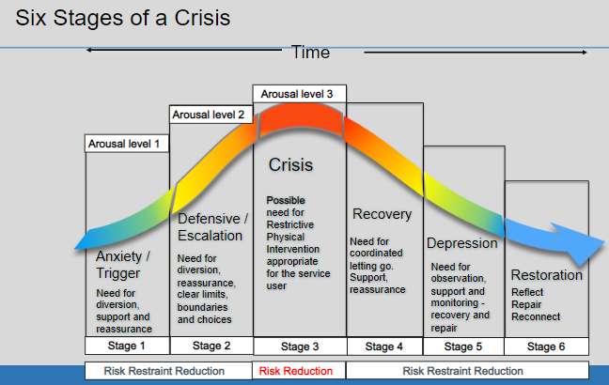

A child with an IPM for behaviour may require a Positive Behaviour Support Plan (PBSP) as part of an Individual Pupil Risk Assessment (IPRA). A PBSP and IPRA would be needed if the child regularly puts themselves, others or property at risk of harm or damage and would detail how adults will intervene in these instances. It may also be needed if a child was regularly compromising the good order or discipline of the school e.g. refusing to leave the classroom when directed. These documents will be kept on the inside of the cupboard in each classroom so that all staff can access them easily.

**Bullying**

Bullying is a subjective and highly emotive experience, which makes it difficult to define.  We consider bullying to be:

* Repetitive, wilful or persistent
* Intentionally harmful, carried out by an individual or a group
* An imbalance of power leaving the victim feeling defenceless

At Farsley Farfield Primary School we will not tolerate any form of bullying. This includes:

* Homophobic bullying
* Racist bullying
* Transgender bullying
* On-line bullying
* Gender bullying

The school’s [anti-bullying policy](https://docs.google.com/document/d/1A4AFEaMwHCbpReBjtsKZTMleb_eIyTea/edit?usp=sharing&ouid=108210748310708905122&rtpof=true&sd=true) sets out measures the school takes to include measures to prevent bullying, including cyberbullying, prejudice-based and discriminatory bullying.

**Sexualised Behaviour**

Keeping Children Safe in Education - ‘Sexual violence and sexual harassment can occur between two children of any age and sex, from primary through to secondary stage and into colleges. It can occur through a group of children sexually assaulting or sexually harassing a single child or group of children. Sexual violence and sexual harassment exist on a continuum and may overlap; they can occur online and face to face (both physically and verbally) and are never acceptable. As set out in Part one of this guidance, all staff working with children are advised to maintain an attitude of ‘**it could happen here**’. The school will ensure that all incidents of sexual harassment and/or violence are met with a suitable response, and neverignored.’

Pupils are encouraged to report anything that makes them uncomfortable, no matter how ‘small’ they feel it might be.

The school’s response will be:

• Proportionate

• Considered

• Supportive

• Decided on a case-by-case basis

Sanctions for sexual harassment and violence may include:

• Educating further on what constitute sexual harassment and why remarks, comments, ‘jokes’ or

taunting etc are unacceptable and providing pastoral support

• Sanctions in line with behaviour policy such as missing break times.

• Providing apologies to the victim if appropriate

• Involving parents for support if to be dealt with internally

• Separating the victim and alleged perpetrator while investigation is underway and possibly beyond to minimise their proximity to each other

• Risk assessments carried out

• Referral for further support through early help if not reporting to children’s social care or the police

The school has procedures in place to respond to any allegations or concerns regarding a child’s safety or

wellbeing. These include clear processes for:

• Responding to a report

• Carrying out risk assessments, where appropriate, to help determine whether to:

o Manage the incident internally

o Refer to early help

o Refer to children’s social care

o Report to the police

Please refer to our child protection and safeguarding policy for more information.

**Reasonable Force**

Staff at Farsley Farfield are trained in Team-teach. This is a programme designed to help staff to calm children and de-escalate difficult situations. It also trains staff to hold children safely if it becomes necessary. Should this occasion arise children and staff will be given time to reflect and find a different way to deal with difficult situations in the future. The actions that we take are in line with government guidelines on the restraint of children. Records

are kept and parents or carers are informed.

**Exclusions**

In instances of very serious behaviours, the Headteacher may exclude a child for a given period of time or permanently. Exclusions will be reported to the governing body.

In the rare case of a permanent exclusion, the Headteacher will follow LEA guidelines which are outlined in a separate policy.

**Malicious Allegations**

Where a child makes an accusation against a member of staff and that accusation is shown to have been malicious, the Head Teacher will discipline the pupil in accordance with this policy. Please refer to our Child Protection policy for more information on responding to allegations of abuse. The Head Teacher will also consider the pastoral needs of staff accused of misconduct.

**Policy Review Date: September 2024**

**Appendix 1** (one-page behaviour guide)

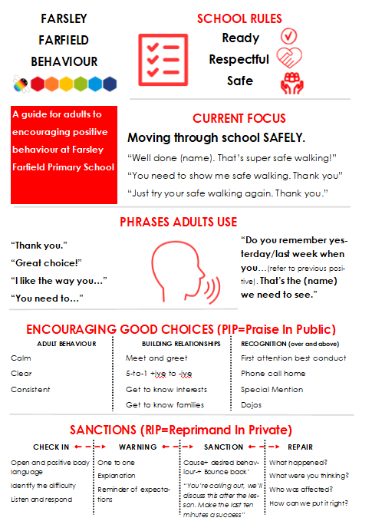

**Appendix 2** (managing and modifying poor behaviour choices)

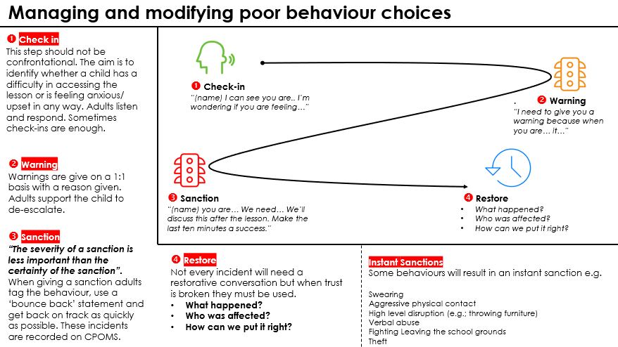

**Appendix 3** (behaviour checklist for school leaders)

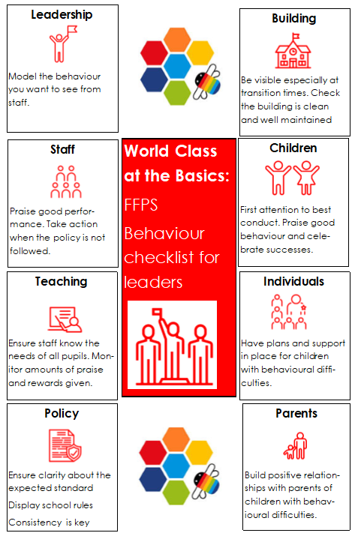

**Appendix 4** (behaviour checklist for classroom staff)

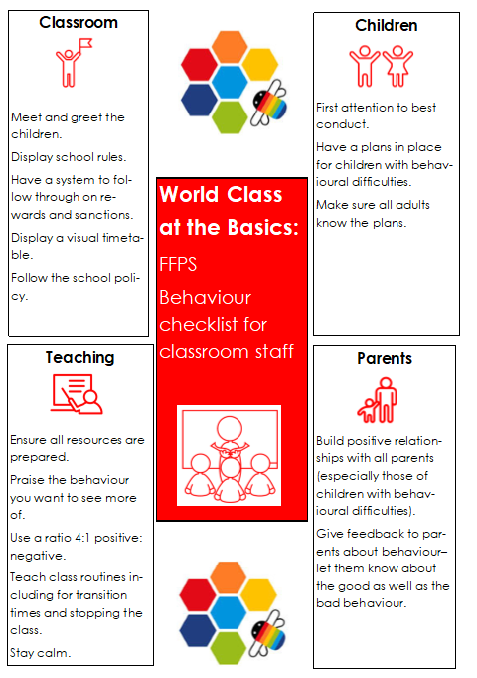

**Appendix 5** (behaviour checklist for lunchtime staff)

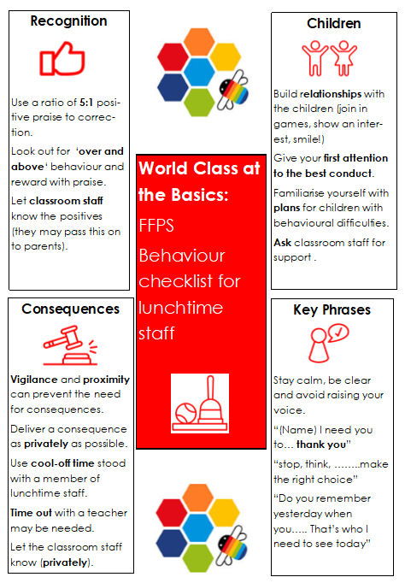

**Appendix 6** (Restorative conversations)

